OSPF Stubby, Totally Stubby, and NSSA Area Setup and Configuration Lab

Joshua Widjaja

P0-2 Cisco CCNP

Mr. Mason

**Purpose:**

The major purpose of this lab was for expose us to the important concept of LSA types. The specific concepts Mr. Mason was trying to get us to learn were how to modify our network to receive LSA type 1, 2, 3, 4, 5, and 7.

**Background Information:**

LSA, also known as Link State Advertisement, is used in the routing protocol used for IP networks called OSPF (Open Shortest Path First). OSPF has numerous distinct types of LSAs, each serving a different purpose.

**LSA Type 1:** Also known as the router LSA, its main purpose is to describe the router’s type of connections (interface or direct links) in its local area. They are found in each router inside an area. LSA Type 1 is flooded only inside the OSPF area to where the advertising belongs and does not leave the boundaries of the area. Results in point-to-point connection to another router. In the link states ID, which identifies what is being advertised by the LSA, you will find the originating router’s ID (used for router to identify itself). Since LSA Type 1 is flooded only within the specific area, it does not cross the area border router (ABR).

**LSA Type 2:** Also known as the network LSA, Type 2 LSAs are generated by the DR (Designated Router) on the broadcast network. An OSPF network with two or more routers will elect one router to serve as the designated router and another as the backup designated router. OSPF will forward all messages to the DR. Type 4 LSAs are used to inform all the routers in a certain network segment that the DR is present and who it is. The link-state ID will be the interface IP address of the DR. Just like LSA Type 1, network LSAs are only flooded within the area and cannot cross the ABR.

**LSA Type 3:** Also known as the Summary LSA, Type 3 LSAs are created by the Area Border Router (ABR) and is used to share the network information with other areas and inter-area routing. An ABR is a router that connects one or more areas to the OSPF backbone. These LSAs are flooded into other areas. They essentially summarize information about networks within an OSPF area to other routers in different areas. By sharing these type 3 LSAs with other areas, it makes inter-area routing possible.

**LSA Type 4:** Also known as the Summary ASBR LSA, Type 4 LSAs are used to help routers within an OSPF area reach the Autonomous System Boundary Router (ASBR) in a certain OSPF area. An ASBR is a router that is running distinct protocols while serving as a gateway to routers when an interface is in OSPF domain and other interfaces connecting to routers operating with different protocols. Type 4 LSAs only contain the Router ID of the ASBR and are necessary to access routes outside the OSPF domain.

**LSA Type 5:** Also known as the autonomous system External LSA, they are used to advertise networks from other Autonomous systems (OSPF Domains). They are specifically advertised by the ASBR and originate from them. These external routes are then redistributed into the OSPF network by the ASBR. Type 5 will give the routes from the ASBR.

**LSA Type 7:** Also known as not-so-stubby-area (NSSA) LSA or external LSA, LSA type 7 is a temporary LSA used for the ASBR for OSPF communication. They are not flooded throughout the entire OSPF domain like other LSAs and are converted into Type 5 LSAs by the ASBR. Once it is converted into Type 5 LSA, it functions as a regular OSPF route advertisement.

OSPF is a routing protocol that uses LSAs (Link State Advertisements) to exchange routing information within an OSPF area. There are also distinct area types to control how routing information flows such as Stubby, totally stubby, and NSSA (not-so-stubby-area).

**Stub Area:** Stub areas do not allow LSA Type 4 and external Type 5 LSAs and only contains internal OSPF routes. External routes come from other routing protocols and are summarized as a default route and Type 3 LSA into that stub area. Stub areas help reduce the size of the OSPF database, making the routing within the area simpler.

**Totally Stubby Area:** A totally stubby area has more restrictions than a stub area because not only does it disallow external routes, but it also blocks inter-area type 3 summary routes. For totally stubby, a single default route is used for all external destinations outside its own area. Just like stub area, totally stubby area also simplifies routing and reduces the size of the OSPF database.

**NSSA (Not-So-Stubby Area):** NSSA is used when you want to introduce external routes into an OSPF area but doesn’t use LSA types 4-5 to do so. You inject external routes as Type 7 LSAs which aren’t flooded throughout the entire OSPF domain and are then converted into type 5 LSAs by the NSSA’s ASBR prior to being sent inside the OSPF domain. NSSAs allow for the introduction of external routes without impacting the rest of the OSPF area.

**Lab Summary:**

We first set up an IP scheme for each router’s interface (g0/0/0 and g0/0/1), setting up ipv4 addresses. We then created a topology based on our IP scheme to help us stay organized. Using the topology, we set up our cables to the matching connecting interfaces. Consoling into each router, we configured our preset ipv4 addresses on each interface we assigned the routers to. We then made sure that interfaces in the same area had the same OSPF area ID and those in different areas had a distinct OSPF area ID (normal OSPF setup). For external routes, the routers that weren’t configured with OSPF had a static route in between them. We then went into router OSPF mode to assign certain areas a different OSPF type. Following the configuration of the stub area, totally stubby area, and NSSA (Snot so stubby area), we used Wireshark to capture the specific LSA types.

**Lab Commands:**

The new commands that I learned required to do this lab were for configuring stub, totally stubby, and not so stubby areas.

Stub Area:

The command used to enable stub area is **(router-config)# area** *area-id* **stub**.

Totally Stub Area:

The command used to enable totally stub area on the ABR (Area Border Router) is **(router-config)# area** *area-id* **stub**.

NSSA (Not So Stubby Area):

The command used to enable NSSA is **(router-config)# area** *area-id* **nssa**

After configuring the different OSPF areas, these were the techniques we used to receive certain LSA Types in Wireshark:

LSA 1 (Router-LSA): **“clear ip ospf process”**. This command restarts the OSPF process, causing it to reestablish neighbor relationships and as a result, seeing this traffic on wireshark.

LSA 2 (Network-LSA): **“clear ip ospf process”.**

LSA 3 (Summary-LSA (IP Network)): **“clear ip ospf process”**. On a totally stubby area, we placed a switch between the routers and then observed the traffic there.

LSA 4 (Summary-LSA (ASBR)): We set a router-id and issued the command, **“redistribute connected subnets”**.  This command tells the router to include subnets that are directly connected to its interfaces in the routing information that will be shared with other routers, thus getting LSA 4 traffic.

LSA 5 (AS-External-LSA (ASBR)): We set a loopback interface and created a default route on it, then issued the command **“redistribute connected subnets”**.

LSA 7 (NSSA AS-External-LSA): We placed a switch in between the routers on a NSSA area and then observed the network there.

**Network Diagram:**

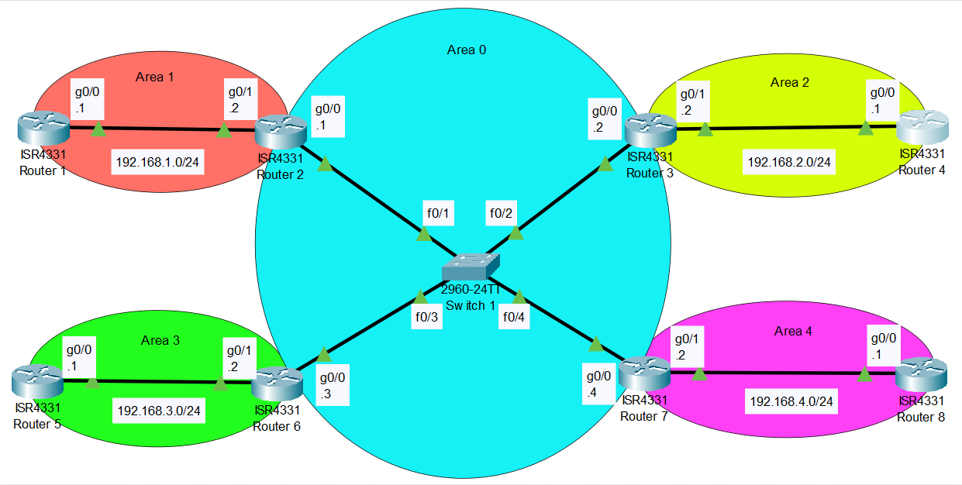

**Configurations:**

**---R1---**

R1#show run  
Building configuration...

Current configuration : 1594 bytes  
  
Last configuration change at 16:39:44 UTC Mon Oct 9 2023  
  
version 16.9  
service timestamps debug datetime msec  
service timestamps log datetime msec  
platform qfp utilization monitor load 80  
no platform punt-keepalive disable-kernel-core  
  
hostname R1  
  
boot-start-marker  
boot-end-marker  
  
vrf definition Mgmt-intf  
  
address-family ipv4  
exit-address-family  
  
address-family ipv6  
exit-address-family9  
  
no aaa new-model  
no ip domain lookup  
  
login on-success log  
  
subscriber templating  
  
vtp domain cisco  
vtp mode transparent  
multilink bundle-name authenticated  
  
license udi pid ISR4321/K9 sn FDO21482HZX  
license boot level appxk9  
no license smart enable  
diagnostic bootup level minimal  
  
spanning-tree extend system-id  
  
redundancy  
mode none  
  
interface GigabitEthernet0/0/0  
ip address 192.168.1.1 255.255.255.0  
negotiation auto  
  
interface GigabitEthernet0/0/1  
no ip address  
negotiation auto  
  
interface Serial0/1/0  
no ip address  
shutdown  
  
interface Serial0/1/1  
no ip address  
shutdown  
  
interface GigabitEthernet0  
vrf forwarding Mgmt-intf  
no ip address  
shutdown  
negotiation auto  
  
router ospf 1  
router-id 1.1.1.1  
redistribute connected subnets  
redistribute bgp 1 subnets  
redistribute eigrp 1 subnets  
network 192.168.1.0 0.0.0.255 area 1  
  
ip forward-protocol nd  
no ip http server  
no ip http secure-server  
ip tftp source-interface GigabitEthernet0  
  
control-plane  
  
line con 0  
transport input none  
stopbits 1  
line aux 0  
stopbits 1  
line vty 0 4  
login  
  
end

**---R2---**

R2#show run  
Building configuration...

Current configuration : 3768 bytes  
  
Last configuration change at 16:44:14 UTC Mon Oct 9 2023  
  
version 16.9  
service timestamps debug datetime msec  
service timestamps log datetime msec  
platform qfp utilization monitor load 80  
platform punt-keepalive disable-kernel-core  
  
hostname R2  
  
boot-start-marker  
boot-end-marker  
  
vrf definition Mgmt-intf  
  
address-family ipv4  
exit-address-family  
  
address-family ipv6  
exit-address-family  
  
no aaa new-model  
  
no ip domain lookup  
  
login on-success log  
  
subscriber templating  
  
vtp domain cisco  
vtp mode transparent  
multilink bundle-name authenticated  
  
crypto pki trustpoint TP-self-signed-2105456491  
enrollment selfsigned  
subject-name cn=IOS-Self-Signed-Certificate-2105456491  
revocation-check none  
rsakeypair TP-self-signed-2105456491  
  
crypto pki certificate chain TP-self-signed-2105456491  
certificate self-signed 01  
  30820330 30820218 A0030201 02020101 300D0609 2A864886 F70D0101 05050030  
  31312F30 2D060355 04031326 494F532D 53656C66 2D536967 6E65642D 43657274  
  69666963 6174652D 32313035 34353634 3931301E 170D3233 30363036 31383232  
  32395A17 0D333030 31303130 30303030 305A3031 312F302D 06035504 03132649  
  4F532D53 656C662D 5369676E 65642D43 65727469 66696361 74652D32 31303534  
  35363439 31308201 22300D06 092A8648 86F70D01 01010500 0382010F 00308201  
  0A028201 0100876A 184F35C6 0E929121 EE3811A8 28E1A40F FD6DDB23 539E0D71  
  8E7E6090 3554D474 46DF5C06 8E68CDAC B1FF1F90 ACF8D30E 20CD2F18 A3D2A9D8  
  AC5627B9 D2163758 C17AEB01 07A8C0CF 3C9C8CF9 ED7074F9 02991FB8 1E7409DD  
  74AEB5A2 40DC020A 5DE53722 7FFD0381 BD09A39C 11C123E4 BE55D472 1607DBD8  
  987513C4 03E13D0D B539E73B 7DF22B0C 7C34FEC8 89133906 8F3BB98B 6D8AD20E  
  0A490E56 48B00F73 80D3F9E9 A8B16B4D 64A6C0B4 C5C65E75 8FEAF49C 2B49687F  
  B150A1EC 6873780E 1AADEF00 CE9F01A6 17C6382D 4D71B2E6 1E4C78DA 5A46E715  
  3EE04254 0DC6B096 180F1EF5 FC4BE073 C1B9221D 3A4C9F87 C15B7860 0EF18D3E  
  54B842D5 0ABD0203 010001A3 53305130 0F060355 1D130101 FF040530 030101FF  
  301F0603 551D2304 18301680 1440DDFF E73B2EAD ED3921BA A11AEE2E 6D45A59B  
  59301D06 03551D0E 04160414 40DDFFE7 3B2EADED 3921BAA1 1AEE2E6D 45A59B59  
  300D0609 2A864886 F70D0101 05050003 82010100 5B8F2495 D377BC11 0B345122  
  96F7CB9A 8003892D F80D3933 C744DFE8 D0C85690 A020EF0C D378F115 D2DFFBD5  
  7A915909 82581749 596387CB B7E832DF CBD3E80B 9C03DB26 DA183114 57E74C7D  
  27386F78 F616A79F 984C1F31 CEEBFC5A A7899161 15D25D18 0E3E64C0 1451C28A  
  E591F4F3 121F95BC E482E801 2886D58F 4B704519 75E997BC 751FCFA9 8C0FD4B5  
  707B872B BAAE459F A94760DE 290E7468 C566D6E4 C2E9AB64 DCD64D7E E4C533E1  
  02C26C97 342238B1 985B5E18 A43B10B3 69E0A5ED 30796592 C66037AE DAFA667A  
  782B7257 3E033740 86EB13DD 6D60C50E C84D2F03 0CF888C6 D1356561 7DB99621  
  79DC8347 077D1D63 E20BC2A1 AF6EC6E2 81F3D397  
        quit  
  
license udi pid ISR4321/K9 sn FDO21482DWJ  
license boot level appxk9  
no license smart enable  
diagnostic bootup level minimal  
  
spanning-tree extend system-id  
  
redundancy  
mode none  
  
interface GigabitEthernet0/0/0  
ip address 192.168.5.1 255.255.255.0  
negotiation auto  
  
interface GigabitEthernet0/0/1  
ip address 192.168.1.2 255.255.255.0  
negotiation auto  
  
interface Serial0/1/0  
no ip address  
shutdown  
  
interface Serial0/1/1  
no ip address  
shutdown  
  
interface GigabitEthernet0  
vrf forwarding Mgmt-intf  
no ip address  
shutdown  
negotiation auto  
  
router ospf 1  
network 192.168.1.0 0.0.0.255 area 1  
network 192.168.5.0 0.0.0.255 area 0  
  
ip forward-protocol nd  
ip http server  
ip http authentication local  
ip http secure-server  
ip tftp source-interface GigabitEthernet0  
  
control-plane  
  
line con 0  
transport input none  
stopbits 1  
line aux 0  
stopbits 1  
line vty 0 4  
login  
  
end

**---R3---**

R3#show run  
Building configuration...

Current configuration : 3781 bytes  
  
Last configuration change at 16:39:30 UTC Mon Oct 9 2023  
  
version 16.9  
service timestamps debug datetime msec  
service timestamps log datetime msec  
platform qfp utilization monitor load 80  
platform punt-keepalive disable-kernel-core  
  
hostname R3  
  
boot-start-marker  
boot-end-marker  
  
vrf definition Mgmt-intf  
  
address-family ipv4  
exit-address-family  
  
address-family ipv6  
exit-address-family   
no aaa new-model  
  
no ip domain lookup  
  
login on-success log  
  
subscriber templating  
  
vtp domain cisco  
vtp mode transparent  
multilink bundle-name authenticated  
  
crypto pki trustpoint TP-self-signed-2949602955  
enrollment selfsigned  
subject-name cn=IOS-Self-Signed-Certificate-2949602955  
revocation-check none  
rsakeypair TP-self-signed-2949602955  
  
crypto pki certificate chain TP-self-signed-2949602955  
certificate self-signed 01  
  30820330 30820218 A0030201 02020101 300D0609 2A864886 F70D0101 05050030  
  31312F30 2D060355 04031326 494F532D 53656C66 2D536967 6E65642D 43657274  
  69666963 6174652D 32393439 36303239 3535301E 170D3233 30363036 31383138  
  33395A17 0D333030 31303130 30303030 305A3031 312F302D 06035504 03132649  
  4F532D53 656C662D 5369676E 65642D43 65727469 66696361 74652D32 39343936  
  30323935 35308201 22300D06 092A8648 86F70D01 01010500 0382010F 00308201  
  0A028201 0100C6B5 B6C310C4 166068B7 15C74E3E 53F7C254 939DBD5B E2434EC9  
  4FCA1119 86013DAA 104B9104 7AE81A7D 62DDA0AE 836E3586 DFDD1E84 5C287973  
  3328DD4D F48BF6D2 52662405 1841E05F B2FF3EC1 CC6A3955 064D5490 C240DEEF  
  3948256A 5BC47454 92A048CD DA5FCAD8 1D745E89 870637FB C36CFC5E 45760A8D  
  0E1BD89A 7EE17E9E 5EAE4702 46DDBF57 6C4D7E5F 2CA008E7 E7E6F775 74DAF7EF  
  D04D09A2 5B427C52 4AB66E61 38508337 E3BCF313 0A40F195 F368478D A335A20B  
  BB701646 D317E6D4 AE6A859F 5AE791B7 8EFC6926 0C73BA7D 7CB96288 7ECF7E1B  
  4B41CCBE 0F56B91F ACBCED21 A0B621ED 5D64DC14 60E2A166 C0245203 A43E7CF8  
  CDB7AE05 368D0203 010001A3 53305130 0F060355 1D130101 FF040530 030101FF  
  301F0603 551D2304 18301680 149E38E7 4A07C2C4 CBC2185B 51B7256D F324FDDC  
  99301D06 03551D0E 04160414 9E38E74A 07C2C4CB C2185B51 B7256DF3 24FDDC99  
  300D0609 2A864886 F70D0101 05050003 82010100 221DD907 7E6116E7 361E4334  
  65D7ED95 6D1BB560 18432F68 9A4E4892 8BF9CD6F 2F1913AE 9B714EDA 2F37A0F0  
  531230DE 107289B1 628BB27F 3DC2CB84 D5E98C24 AB0D0D96 C8AEE293 3DEA769F  
  6DCA8267 1E50F272 EDDADF26 AC33371C B79A996A 83B6F7F7 DBF7FAEA D1B71FA3  
  07A5319B C545D7E5 7BC1C54F 1AC38B70 1AE6A10A 94A6F479 913EDB2C 971832C2  
  624DE6A7 3539E597 89CFAAAB 8B91A963 8B7A37FD 64EABCE8 C9A9AE43 92C3C0FF  
  86C8894E 21B2743D 07522338 EE69AE4A FD968EE7 A8FB88BF 42858824 86583368  
  C267EDAE 753390AB 5EFD923F 925102BF 9CCA72C1 2BA44FE4 8918CB12 B9D8A1FC  
  F2B9E102 5E585CE2 F980BAC1 D9C5AD01 338D1CB9  
        quit  
  
license udi pid ISR4321/K9 sn FDO214420HW  
license boot level appxk9  
no license smart enable  
diagnostic bootup level minimal  
  
spanning-tree extend system-id  
  
redundancy  
mode none  
  
interface GigabitEthernet0/0/0  
ip address 192.168.5.2 255.255.255.0  
negotiation auto  
  
interface GigabitEthernet0/0/1  
ip address 192.168.2.2 255.255.255.0  
negotiation auto  
  
interface Serial0/1/0  
no ip address  
shutdown  
  
interface Serial0/1/1  
no ip address  
shutdown  
  
interface GigabitEthernet0  
vrf forwarding Mgmt-intf  
no ip address  
shutdown  
negotiation auto  
  
router ospf 1  
area 2 stub  
network 192.168.2.0 0.0.0.255 area 2  
network 192.168.5.0 0.0.0.255 area 0  
  
ip forward-protocol nd  
ip http server  
ip http authentication local  
ip http secure-server  
ip tftp source-interface GigabitEthernet0  
  
control-plane  
  
line con 0  
transport input none  
stopbits 1  
line aux 0  
stopbits 1  
line vty 0 4  
login  
  
end

**---R4---**

R4#show run  
Building configuration...

Current configuration : 3632 bytes

Last configuration change at 16:33:01 UTC Mon Oct 9 2023  
  
version 16.9  
service timestamps debug datetime msec  
service timestamps log datetime msec  
platform qfp utilization monitor load 80  
platform punt-keepalive disable-kernel-core  
  
hostname R4  
  
boot-start-marker  
boot-end-marker  
  
vrf definition Mgmt-intf  
  
address-family ipv4  
exit-address-family  
  
address-family ipv6  
exit-address-family  
  
no aaa new-model  
  
login on-success log  
  
subscriber templating  
vtp domain cisco  
vtp mode transparent  
multilink bundle-name authenticated  
  
crypto pki trustpoint TP-self-signed-262078645  
enrollment selfsigned  
subject-name cn=IOS-Self-Signed-Certificate-262078645  
revocation-check none  
rsakeypair TP-self-signed-262078645  
  
crypto pki certificate chain TP-self-signed-262078645  
certificate self-signed 01  
  3082032E 30820216 A0030201 02020101 300D0609 2A864886 F70D0101 05050030  
  30312E30 2C060355 04031325 494F532D 53656C66 2D536967 6E65642D 43657274  
  69666963 6174652D 32363230 37383634 35301E17 0D323331 30303931 35323831  
  325A170D 33303031 30313030 30303030 5A303031 2E302C06 03550403 1325494F  
  532D5365 6C662D53 69676E65 642D4365 72746966 69636174 652D3236 32303738  
  36343530 82012230 0D06092A 864886F7 0D010101 05000382 010F0030 82010A02  
  82010100 C5FCDB1F AED460EB F69E6EB1 811288E6 0224232B B8B0A431 F65CAB51  
  7771820E A972EF7C 4C2F74B0 0C081313 719F58B7 5A052E79 66EE130B C836788A  
  ABEA22E8 FF32E4C4 6E70213C A529F6F7 58AB0210 95D16530 D7EAD699 D9FEAE09  
  925283F0 ADA98062 FDB2BE42 A34E4F19 05564221 5E21A2CA F0840BBD 5C9A22AB  
  6308A394 8C1F5CCF 22BD342C C59440D5 833EC6AB 6602B48B CE12BCAB 21459F11  
  5A6781A4 9B992E47 DF4B61A1 65083734 93DEFA60 537DA8B4 D0A19020 A43F859A  
  F52E60CF D2D0B192 8986630A A02C06D3 F4511A09 A91A0F95 60BB3AA1 FAB576D0  
  DA2F5103 4F57CC83 80D6D815 3A1EFE21 9AD22488 5B98D0C6 4636F3FA 21B75574  
  5ED61111 02030100 01A35330 51300F06 03551D13 0101FF04 05300301 01FF301F  
  0603551D 23041830 168014CF 9FB585C5 CA49A79E 76156BAA 9912E141 8170A530  
  1D060355 1D0E0416 0414CF9F B585C5CA 49A79E76 156BAA99 12E14181 70A5300D  
  06092A86 4886F70D 01010505 00038201 01002ACD FB26CD3F 13A5EECF D24E275E  
  F0101AE2 836AEBC6 DA1A99F3 B3F21AFE 1EB8157F 56AE566E 3AB1C4BF 40677F90  
  809FFFCE BFB13A85 F9F0317B 5E3AA2AC 1D52A8BD 43036E2B 77E27876 42706CA6  
  2CDE99D6 D16EA2C3 8CF75343 FFE5F58D F1E249F6 A3401019 B1DA6B5E 9E82A4B6  
  F79C2127 5D10D0CC 5DB5A587 C1C42F9B 1D192B1E 2841B412 28BC450E 782D80E5  
  174E17B6 F434C77F 1DB527EB F7889FBC 4C6211F8 A5F36FE6 8A8ACDB6 8AEE8623  
  E54E3D11 D0E24477 520CC578 A5A64CD9 69BE820F EC23FDFF 1D81646E D2743A5F  
  25E389C6 6CC03577 9DAC0D89 156EEA5D 688612BC F402F878 FD3D9822 F7E9B061  
  36777A32 0AE0693D 46B3513B 02742BE1 4ED8  
        quit  
  
license udi pid ISR4321/K9 sn FDO214421D1  
no license smart enable  
diagnostic bootup level minimal  
  
spanning-tree extend system-id  
  
redundancy  
mode none  
  
interface GigabitEthernet0/0/0  
ip address 192.168.2.1 255.255.255.0  
negotiation auto  
  
interface GigabitEthernet0/0/1  
no ip address  
negotiation auto  
  
interface Serial0/1/0  
no ip address  
shutdown  
  
interface Serial0/1/1  
no ip address  
shutdown  
  
interface GigabitEthernet0  
vrf forwarding Mgmt-intf  
no ip address  
shutdown  
negotiation auto  
router ospf 1  
area 2 stub  
network 192.168.2.0 0.0.0.255 area 2  
  
ip forward-protocol nd  
ip http server  
ip http authentication local  
ip http secure-server  
ip tftp source-interface GigabitEthernet0  
  
control-plane  
  
line con 0  
transport input none  
stopbits 1  
line aux 0  
stopbits 1  
line vty 0 4  
login  
  
end

**---R5---**

R5#show run  
Building configuration...

Current configuration : 3689 bytes  
  
Last configuration change at 16:36:09 UTC Mon Oct 9 2023  
  
version 16.9  
service timestamps debug datetime msec  
service timestamps log datetime msec  
platform qfp utilization monitor load 80  
no platform punt-keepalive disable-kernel-core  
  
hostname R5  
  
boot-start-marker  
boot-end-marker  
  
vrf definition Mgmt-intf  
  
address-family ipv4  
exit-address-family  
  
address-family ipv6  
exit-address-family  
  
no aaa new-model  
  
login on-success log  
  
subscriber templating  
vtp domain cisco  
vtp mode transparent  
multilink bundle-name authenticated  
  
crypto pki trustpoint TP-self-signed-859896477  
enrollment selfsigned  
subject-name cn=IOS-Self-Signed-Certificate-859896477  
revocation-check none  
rsakeypair TP-self-signed-859896477  
  
crypto pki certificate chain TP-self-signed-859896477  
certificate self-signed 01  
  3082032E 30820216 A0030201 02020101 300D0609 2A864886 F70D0101 05050030  
  30312E30 2C060355 04031325 494F532D 53656C66 2D536967 6E65642D 43657274  
  69666963 6174652D 38353938 39363437 37301E17 0D323231 30313731 38323635  
  385A170D 33303031 30313030 30303030 5A303031 2E302C06 03550403 1325494F  
  532D5365 6C662D53 69676E65 642D4365 72746966 69636174 652D3835 39383936  
  34373730 82012230 0D06092A 864886F7 0D010101 05000382 010F0030 82010A02  
  82010100 CA31EE51 C97FF58C 76C72B4E 2B6CD51B 98CBA177 7EEF8D11 DAAB7CA8  
  47B3AA97 3B815AD1 09F637AE B1D98BB8 A2CAA1A9 0AFAF87A 3AFBFF9E 34875D72  
  0BD5EE8D E40F4D4A 3B4A38A7 09F1940D 013C18AE F29F2BEA 07085EB5 982E9BC8  
  F99C8CA7 1C7DD58E 67B89FCB 951C3C4C 6D11B8C7 8D24BF5C 973A32BF E16A3094  
  99E8DB22 7FEA5A30 6E9457F6 90485336 E953F3D2 942824E3 87D8DE52 E00336AC  
  09CA85F0 0BD105FA B4078F96 9A2EA846 C147AD42 B08CD3D2 16A06EB1 CC54E167  
  8F4677E9 2663D37D 7B1C3891 9ABF4B5B 83ECE428 AD426108 357B992E 792C850D  
  84C67187 BF0E10B5 B1D23A97 F2F1372F 7D0FA8C8 80E947DE 5E0FA234 7FA6A487  
  24A0DB83 02030100 01A35330 51300F06 03551D13 0101FF04 05300301 01FF301F  
  0603551D 23041830 168014E7 C71AF39E FCC743E7 C7395603 DBBCA771 4C734E30  
  1D060355 1D0E0416 0414E7C7 1AF39EFC C743E7C7 395603DB BCA7714C 734E300D  
  06092A86 4886F70D 01010505 00038201 010029B2 769B6033 C71585B8 DD1EE596  
  BDB3F81C 5C58921E AF7FBE2F A95F447D 7B870BCD B9AE5E5D 46FCE0E1 667295B7  
  4668DACB F848F91A 207FC6CD 203E64BF 6747B9E7 6FF304F1 491442EA 56EEBEE6  
  DE79EC87 F5BE7B9C B2482264 A58FAC1B 827F66C7 F16C0292 815AD1ED 86F2E167  
  9568FC20 9E2ADCB6 311B34E4 E93EC128 2DD25078 4F27E1F1 4DD309BA B2A0248A  
  C41F66C8 4A81C2B8 9D0E8A62 4E0443F6 F28B3203 28A14D43 0E06A98B 06DAB16D  
  66E0616A DB63132A 8FB53D9B 88A28660 F84CD05D EC8653F6 C3FC6446 94977DAC  
  0ED87E1C 9C0B372A 6E25729B FAD2B249 6FDF7BC6 3218B110 D167D3D5 AEACB17D  
  6E8CB48E ED168D18 8D9104DE BA9F3515 5662  
        quit  
  
license udi pid ISR4321/K9 sn FLM240608PJ  
no license smart enable  
diagnostic bootup level minimal  
  
spanning-tree extend system-id  
  
redundancy  
mode none  
  
interface GigabitEthernet0/0/0  
ip address 192.168.3.1 255.255.255.0  
negotiation auto  
  
interface GigabitEthernet0/0/1  
no ip address  
negotiation auto  
  
interface GigabitEthernet0/1/0  
no ip address  
shutdown  
negotiation auto  
  
interface GigabitEthernet0/1/1  
no ip address  
shutdown  
negotiation auto  
  
interface GigabitEthernet0  
vrf forwarding Mgmt-intf  
no ip address  
shutdown  
negotiation auto  
  
router ospf 1  
area 3 stub  
network 192.168.3.0 0.0.0.255 area 3  
  
ip forward-protocol nd  
ip http server  
ip http authentication local  
ip http secure-server  
ip tftp source-interface GigabitEthernet0  
  
control-plane  
  
line con 0  
transport input none  
stopbits 1  
line aux 0  
stopbits 1  
line vty 0 4  
login  
  
end

**---R6---**

R6#show run  
Building configuration...

Current configuration : 3786 bytes  
  
Last configuration change at 16:37:41 UTC Mon Oct 9 2023  
  
version 16.9  
service timestamps debug datetime msec  
service timestamps log datetime msec  
platform qfp utilization monitor load 80  
platform punt-keepalive disable-kernel-core  
  
hostname R6  
  
boot-start-marker  
boot-end-marker  
  
vrf definition Mgmt-intf  
  
address-family ipv4  
exit-address-family  
  
address-family ipv6  
exit-address-family  
  
no aaa new-model  
  
no ip domain lookup  
  
login on-success log  
  
subscriber templating  
vtp domain cisco  
vtp mode transparent  
multilink bundle-name authenticated  
  
crypto pki trustpoint TP-self-signed-4288135047  
enrollment selfsigned  
subject-name cn=IOS-Self-Signed-Certificate-4288135047  
revocation-check none  
rsakeypair TP-self-signed-4288135047   
crypto pki certificate chain TP-self-signed-4288135047  
certificate self-signed 01  
  30820330 30820218 A0030201 02020101 300D0609 2A864886 F70D0101 05050030  
  31312F30 2D060355 04031326 494F532D 53656C66 2D536967 6E65642D 43657274  
  69666963 6174652D 34323838 31333530 3437301E 170D3233 31303039 31363336  
  33315A17 0D333030 31303130 30303030 305A3031 312F302D 06035504 03132649  
  4F532D53 656C662D 5369676E 65642D43 65727469 66696361 74652D34 32383831  
  33353034 37308201 22300D06 092A8648 86F70D01 01010500 0382010F 00308201  
  0A028201 01009F5A 791DC8C4 06324AE1 7DD58FBB C1AF5FBB 0B01323C 93EB55A3  
  A8A1C83A 6800E29F 89ABE518 7E8DDE58 B9EFC9D8 9EA525DE 8AC83700 8B80991A  
  B18E1E0C AC5BFF52 7B93603C 1048F8AF DE783C0D D5E038B3 79E3F275 EF638973  
  DE014189 5B958E4F 512CD584 C166096F 4D24CC23 F153F4B5 32897AA5 8D1D3375  
  5F0BFF62 7959F572 B60104E0 CEA13B6C A7609A2C 52C30836 FAE59F8A 639A77E1  
  A6BBFC09 D9ADF79D 709B2098 1F156BB7 709FD1B1 E73E08BF 80C98089 5AE97CA6  
  1D3A9521 151C23E1 F589C7C4 85EE2B4B 59FB53B4 2A9BB619 5C0E8FE0 AFDDDA0F  
  4C96E34B BA23BA88 896682B4 13B94755 C959F5CD 6F51C20B 60A89151 18F94017  
  8A446959 5B570203 010001A3 53305130 0F060355 1D130101 FF040530 030101FF  
  301F0603 551D2304 18301680 14B3145A EF3ECC33 0D6AE619 F12DBB0A CB1B6497  
  A3301D06 03551D0E 04160414 B3145AEF 3ECC330D 6AE619F1 2DBB0ACB 1B6497A3  
  300D0609 2A864886 F70D0101 05050003 82010100 2B837B0F 6F3E4E2D DEAA4A8E  
  68A04DA7 815136F5 CE98072D DD9A9BAB 81030FD9 9B6C80BA 36BBD333 BF4BB97B  
  C9E17EF0 C3C0AF80 103B3F23 3EAE761F 7FF9D710 5507C471 22D33A44 91BE08DC  
  9CE065B2 4294E1A9 22B30D9C FFE2DAC0 10A929AF 841D51F3 FCC4DA9A 0AEA6C6A  
  BF0997C4 B7F88F0E 98B1CD69 950A31D3 F1D15417 31882BE2 43A3A142 2001FF14  
  B14A888D AA5C536A D5B74C8E 76969E91 26144E32 D2D20900 304AE407 94B74ADA  
  3DBD14E9 0F4DFE1D 4FCCEEFA DBE87DB9 C8F1EF04 FC1AE094 9A969B48 4304D36B  
  B903003C 54BC60ED 3323ADD5 F07E5427 0E136718 F142F790 133318BE E7392167  
  D4747EA6 C56E9969 FBFA0B28 DF6B8504 57F47F85  
        quit  
  
license udi pid ISR4321/K9 sn FLM2406090M  
no license smart enable  
diagnostic bootup level minimal  
  
spanning-tree extend system-id  
  
redundancy  
mode none  
  
interface GigabitEthernet0/0/0  
ip address 192.168.5.3 255.255.255.0  
negotiation auto  
  
interface GigabitEthernet0/0/1  
ip address 192.168.3.2 255.255.255.0  
negotiation auto  
  
interface GigabitEthernet0/1/0  
no ip address  
shutdown  
negotiation auto  
  
interface GigabitEthernet0/1/1  
no ip address  
shutdown  
negotiation auto  
  
interface GigabitEthernet0  
vrf forwarding Mgmt-intf  
no ip address  
shutdown  
negotiation auto  
  
router ospf 1  
area 3 stub no-summary  
network 192.168.3.0 0.0.0.255 area 3  
network 192.168.5.0 0.0.0.255 area 0  
  
ip forward-protocol nd  
ip http server  
ip http authentication local  
ip http secure-server  
ip tftp source-interface GigabitEthernet0  
  
control-plane  
  
line con 0  
transport input none  
stopbits 1  
line aux 0  
stopbits 1  
line vty 0 4  
login  
  
end

**---R7---**

R7#show run  
Building configuration...

Current configuration : 3717 bytes  
  
Last configuration change at 16:35:23 UTC Mon Oct 9 2023  
  
version 16.9  
service timestamps debug datetime msec  
service timestamps log datetime msec  
platform qfp utilization monitor load 80  
platform punt-keepalive disable-kernel-core  
  
hostname R7  
boot-start-marker  
boot-end-marker  
  
vrf definition Mgmt-intf  
  
address-family ipv4  
exit-address-family  
  
address-family ipv6  
exit-address-family  
  
no aaa new-model  
  
login on-success log  
  
subscriber templating  
multilink bundle-name authenticated  
  
crypto pki trustpoint TP-self-signed-2667303412  
enrollment selfsigned  
subject-name cn=IOS-Self-Signed-Certificate-2667303412  
revocation-check none  
rsakeypair TP-self-signed-2667303412  
  
crypto pki certificate chain TP-self-signed-2667303412  
certificate self-signed 01  
  30820330 30820218 A0030201 02020101 300D0609 2A864886 F70D0101 05050030  
  31312F30 2D060355 04031326 494F532D 53656C66 2D536967 6E65642D 43657274  
  69666963 6174652D 32363637 33303334 3132301E 170D3233 31303039 31363334  
  30315A17 0D333030 31303130 30303030 305A3031 312F302D 06035504 03132649  
  4F532D53 656C662D 5369676E 65642D43 65727469 66696361 74652D32 36363733  
  30333431 32308201 22300D06 092A8648 86F70D01 01010500 0382010F 00308201  
  0A028201 0100D54A 9CEE75FE 95321020 43808E9F FA7B713F 5AF2A980 FE1B0930  
  51052456 1ECD3262 9AF003E3 F5247E19 11D7C241 3CC5755D 8357AC48 46D6D968  
  E9278142 E57A939B D77C6870 367DAC1B 0B8D2A8D C910428C 9BFB47DF 578CA786  
  02C7BD66 BC40FB22 F7C7A83E 6B88A57A CBE7ABE7 C8CC7654 DB721BDF 7582C32D  
  40C1B5AA A2336D1A CACF774C B76972A2 E257F8D4 AD72E3DB A0C3CADF 8D578E53  
  AEB1ACC4 7AB03EC0 C8B021FD 9BA581A7 383693FF 4FE8CAA4 E52F8DAB C7A8250D  
  0FE1D884 AEC7471F 8FA9B133 55FBF863 5D6EBDD8 D15A180D 7CE84E82 720026F9  
  2DD66033 22F8A4ED F8E29FB5 5EC64C45 C786F534 AA300B98 94130255 9D49BDCE  
  A9F29073 CA3D0203 010001A3 53305130 0F060355 1D130101 FF040530 030101FF  
  301F0603 551D2304 18301680 14100F54 699A8028 3C2732D9 8FCB7A12 025BF8DE  
  9A301D06 03551D0E 04160414 100F5469 9A80283C 2732D98F CB7A1202 5BF8DE9A  
  300D0609 2A864886 F70D0101 05050003 82010100 91CD36B8 8F71DAC7 462B4F0A  
  363D9D79 A758FAD0 2981B83F CE6E5AAA 5AED6BFA A5D88E89 CBA605F1 A96AAB7D  
  9BBB441A 99CCF617 C7351D0B EB93AECA BEC13FF2 6A2E3F99 DE67FC42 F6A3452C  
  20C69149 25F09ED4 EFE5373C F6413905 EBCDA66E AD5523A8 8E811ED7 76B034DD  
  118DB877 BDF2F8EE 2ADA3459 32808882 39B27519 0B98A4CB A37FB2AF 96387C8F  
  E3F122DB D1E249D7 F483BF4D 32FB25B8 282ECA60 0D195CB8 A4E14771 1ADB42B4  
  60C6B119 729C4571 45FD43B0 3F934C47 E36D5BBA C8F7CEBE 411F192B FC2FF431  
  63CA3ABA 61FEB9CD 0BB61006 B372B10B C1CE012D 660C5539 B00746F8 9144FF7A  
  7C19386F C14CCAE2 95E82C39 8B0EC46F DEC0D8A6  
        quit  
  
license udi pid ISR4321/K9 sn FLM2407011F  
no license smart enable  
diagnostic bootup level minimal  
  
spanning-tree extend system-id  
  
redundancy  
mode none  
--More--  
*Oct  9 16:35:41.713: %OSPF-5-ADJCHG: Process 1, Nbr 192.168.5.1 on GigabitEthernet0/0/0 from LOADING to FULL, Loading Done  
*Oct  9 16:35:41.713: %OSPF-5-ADJCHG: Process 1, Nbr 192.168.5.2 on GigabitEthernet0/0/0 from LOADING to FULL, Lo!        e  
  
interface GigabitEthernet0/0/0  
ip address 192.168.5.4 255.255.255.0  
negotiation auto  
  
interface GigabitEthernet0/0/1  
ip address 192.168.4.2 255.255.255.0  
negotiation auto  
  
interface GigabitEthernet0/1/0  
no ip address  
shutdown  
negotiation auto  
  
interface GigabitEthernet0/1/1  
no ip address  
shutdown  
negotiation auto  
  
interface GigabitEthernet0  
vrf forwarding Mgmt-intf  
no ip address  
shutdown  
negotiation auto  
  
router ospf 1  
area 4 nssa  
network 192.168.4.0 0.0.0.255 area 4  
network 192.168.5.0 0.0.0.255 area 0  
  
ip forward-protocol nd  
ip http server  
ip http authentication local  
ip http secure-server  
ip tftp source-interface GigabitEthernet0  
  
control-plane  
  
line con 0  
transport input none  
stopbits 1  
line aux 0  
stopbits 1  
line vty 0 4  
login  
  
end

**---R8---**

R8#show run  
Building configuration...

Current configuration : 3685 bytes  
  
Last configuration change at 17:01:22 UTC Mon Oct 9 2023  
  
version 16.9  
service timestamps debug datetime msec  
service timestamps log datetime msec  
platform qfp utilization monitor load 80  
platform punt-keepalive disable-kernel-core  
  
hostname R8  
  
boot-start-marker  
boot-end-marker  
vrf definition Mgmt-intf  
  
address-family ipv4  
exit-address-family  
  
address-family ipv6  
exit-address-family  
  
no aaa new-model  
  
no ip domain lookup  
  
login on-success log  
  
subscriber templating  
vtp domain cisco  
vtp mode transparent  
multilink bundle-name authenticated  
  
crypto pki trustpoint TP-self-signed-2951285168  
enrollment selfsigned  
subject-name cn=IOS-Self-Signed-Certificate-2951285168  
revocation-check none  
rsakeypair TP-self-signed-2951285168  
  
crypto pki certificate chain TP-self-signed-2951285168  
certificate self-signed 01  
  30820330 30820218 A0030201 02020101 300D0609 2A864886 F70D0101 05050030  
  31312F30 2D060355 04031326 494F532D 53656C66 2D536967 6E65642D 43657274  
  69666963 6174652D 32393531 32383531 3638301E 170D3233 31303039 31373030  
  33305A17 0D333030 31303130 30303030 305A3031 312F302D 06035504 03132649  
  4F532D53 656C662D 5369676E 65642D43 65727469 66696361 74652D32 39353132  
  38353136 38308201 22300D06 092A8648 86F70D01 01010500 0382010F 00308201  
  0A028201 0100B2D9 514ADE65 955D7169 23D5831A E256F2A7 460BAAD4 4DAE2240  
  AF18C5E4 58222D03 773A74FC 4E7E3B23 5FAECE2C D9AF12C3 D6E6690A E3FD55A9  
  140CAC35 B309907A 74299694 77A6C53E 407B2B3B 4B2E96E8 641C6FAF F151C41B  
  D5D1377D 6C4661CB C99EE9B6 C1271073 8B56AA4F 0A107443 74634F2D BA0A32FC  
  5CD52006 3A09DAF4 57C16833 DD47FEA9 6EFB4009 AA826DEC B1994069 F008ED20  
  51AC529A A764CD14 404A653E 0990A00B 6AEDF741 5622932E 30696E1F D23A1226  
  F530EB74 1E3CC33A 625AE3B0 98630802 526650A9 2A118E90 22D6932B 453AE869  
  D9228B98 31EE0267 F9936ABD 405287D9 7775D069 1891401C 63CC7CC2 4C50FE5A  
  B56BCC27 D49F0203 010001A3 53305130 0F060355 1D130101 FF040530 030101FF  
  301F0603 551D2304 18301680 14157C6C 3FAFB117 25EC589F DB2F0226 C2015BFC  
  EC301D06 03551D0E 04160414 157C6C3F AFB11725 EC589FDB 2F0226C2 015BFCEC  
  300D0609 2A864886 F70D0101 05050003 82010100 69AD3233 A2C03387 46BBEB85  
  034C107C 8D2E5218 C163D950 827159A1 0AA7A4BA CA13012E FEB2E52D 83BB696F  
  4052B42D 3C66BD62 71A2538C 888DD7C3 DA8A9D79 3558DA41 F39A42A6 A1AE534C  
  7B74A120 CB7AF548 FA923123 7F08D8D3 46C3AD04 E3866288 396F6799 FC15309E  
  A76AC26D 12661706 A7DDF334 7D3783AA A9B683B1 DF6A4498 B756B3C4 881553E6  
  8FE0E0CD C52D08F1 B1E9BF54 034478A5 94D2DCDA E9496D47 D3FC66C6 223385EF  
  708A1977 8995BB27 E3882FA8 3902C34A 236CA865 E7B60D98 0FBC5561 063F097B  
  EC98C497 10E5C30E 04160F02 E496F78D A2213A1C 419613BA 4964B52B 69F012A1  
  7D155F02 DE7F3E6D 4ABD1953 9583A279 84928E75  
        quit  
  
license udi pid ISR4321/K9 sn FLM240608H7  
no license smart enable  
diagnostic bootup level minimal  
  
spanning-tree extend system-id  
  
redundancy  
mode none  
  
interface Loopback0  
ip address 4.4.4.4 255.255.255.0  
  
interface GigabitEthernet0/0/0  
ip address 192.168.4.1 255.255.255.0  
negotiation auto  
  
interface GigabitEthernet0/0/1  
no ip address  
negotiation auto  
  
interface GigabitEthernet0  
vrf forwarding Mgmt-intf  
no ip address  
shutdown  
negotiation auto  
  
router ospf 1  
area 4 nssa  
redistribute connected subnets  
network 192.168.4.0 0.0.0.255 area 4  
  
ip forward-protocol nd  
ip http server  
ip http authentication local  
ip http secure-server  
ip tftp source-interface GigabitEthernet0  
ip route 0.0.0.0 0.0.0.0 Loopback0  
  
control-plane  
  
line con 0  
transport input none  
stopbits 1  
line aux 0  
stopbits 1  
line vty 0 4  
login  
  
end

**---LSA Types Shown in Wireshark---**

**LSA Type 1:**

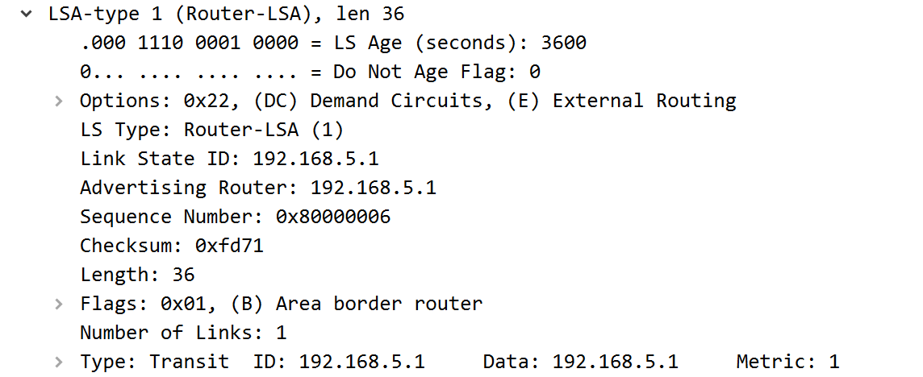

**LSA Type 2:**

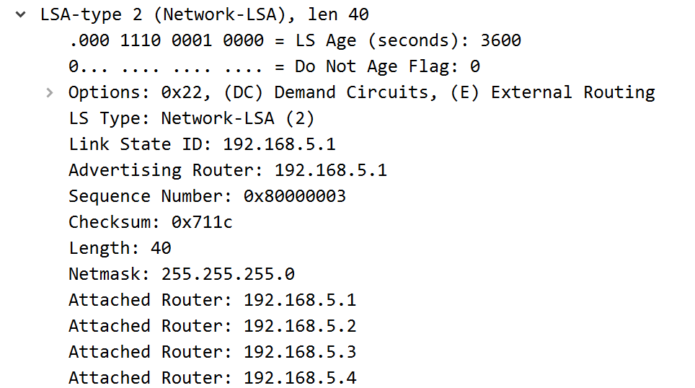

**LSA Type 3 (Stub):**

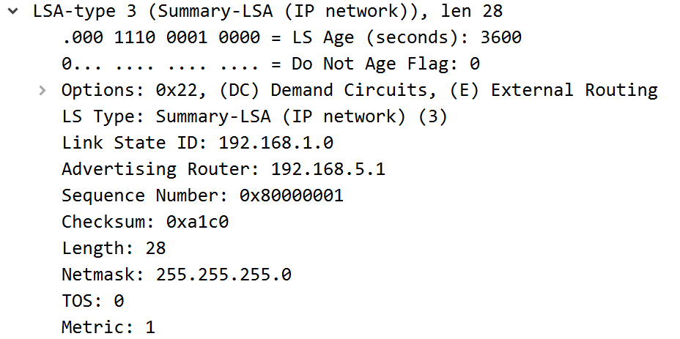

**LSA Type 3 (Totally Stub):**

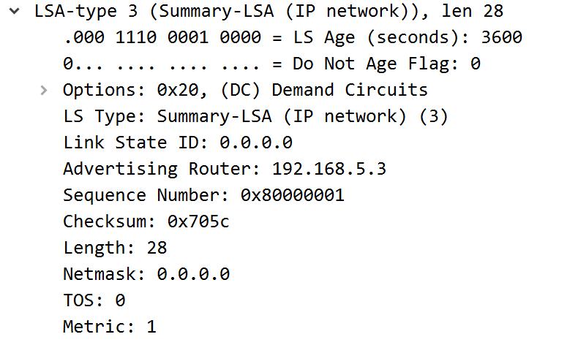

**LSA Type 4:**

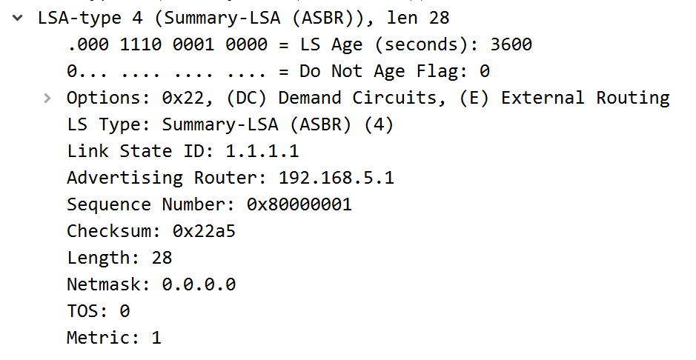

**LSA Type 5:**

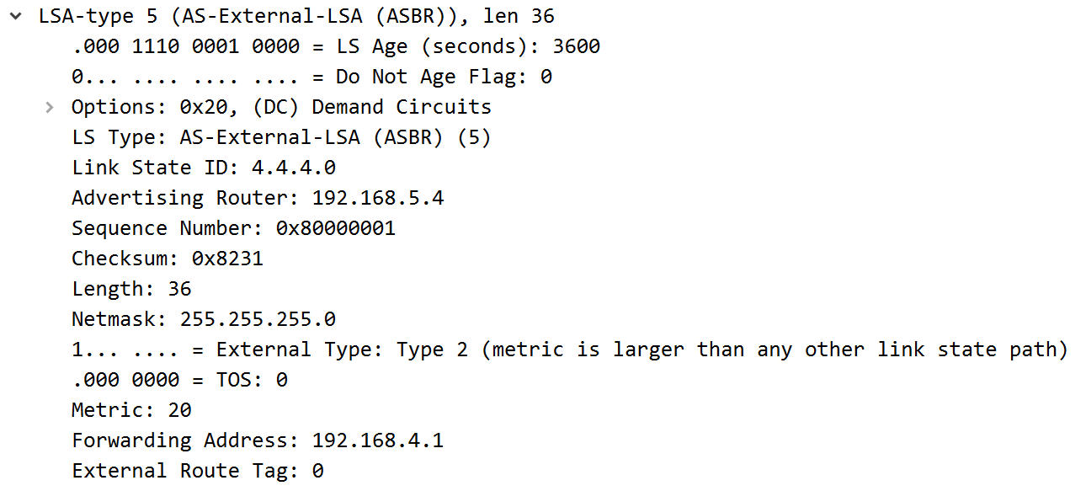

**LSA Type 7:**

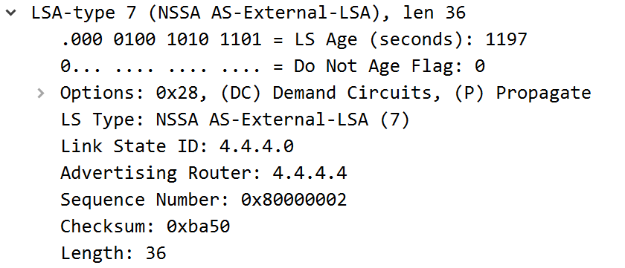

**Problem:**

The first problem we faced was setting up our topology. We set area 0 for the stubby area and went incrementally up in setting the other areas. The problem with this was that we didn’t have a backbone area set, which caused us to have connection issues between different OSPF areas. The backbone area is essential because it is a central piece of a network that distributes routing information between non-backbone routers. Once we set the central hub of our network connecting the different areas together as backbone area 0, we had inter-area connectivity. When attempting to receive LSA Type 3 on a totally stubby area in Wireshark, we initially thought we simply had to enter the command “clear ip ospf process” on the ABR on that totally stubby area, similar to the process in receiving LSA 3 on the stub area. When we weren’t receiving Type 3 LSAs on the totally stubby area, we did further research and found out that we had to place a switch between the routers. Since the routers were directly connected, and Wireshark needed an ethernet connection into the router, we couldn’t connect two wires into one port. Thus, a switch was required to use one of the ports as an ethernet connection to then observe the traffic there. Once this was configured, we received Type 3 LSAs on the totally stubby area in Wireshark. This also applied for us in getting LSA Type 7 to show up in Wireshark as well.

**Conclusion:**

When completing this lab, I learned about certain OSPF area types and the different LSA types that correspond to each of them. We gained further knowledge on the traffic we could catch on Wireshark such as the LSA types. The biggest help to us in gaining initial knowledge on OSPF area and LSA types was through certain websites such as ipwithease.com, networkstraining.com, and others. We continued to use helpful websites such as these to guide us through the configuration. When we got stuck and weren’t able to find our problem by looking at these websites, we resorted to asking our fellow CCNP classmates which was the biggest help when we were having problems. I learned that there should be no shame in asking classmates for help because they are people who have gone through the same steps of the lab and are more than willing to help out.

**Teacher Signoff Page of Lab Completed:**

